Recon External Search Setup Guide

Table of Contents
Section | Page
1. Introduction | 4
- Purpose of the Document | 4
- Overview of External Search Configuration | 4
2. Recon External Search Configuration | 5
- Custom Metadata: API_Configuration__mdt | 5
3. Basic Configuration Information | 5
- Configuration Name | 5
- API Endpoint URL | 5
- Select Method (GET, POST) | 5
- Select Authentication Type | 5
4. Conditional Authentication Details | 6
- API Key Authentication | 6
- OAuth Authentication | 6
- Basic Authentication | 6
- Access Token | 6
5. Additional Request and Response Configuration | 6
- Query Parameters | 7
- Request Body Mapping | 7
- Response Structure Mapping | 8
- Headers | 9
6. Metadata and Query Enhancements | 11
- Is Metadata Available? | 11
- Object Name | 11
- Matching Field to Query | 12
- Fields to Query | 12
- Parent ID Field Name | 12
- Parent SObject Field Name | 12
7. Creating New Configuration | 12
- Prerequisites | 13
- Field Inputs & Formats | 13
- Notes on Remote Site Settings | 14
- Editing or Deleting Configuration | 15
8. Enabling Dynamic Search for Any Object | 17
- Navigating to Object Settings | 17
- Page Layout Changes | 18
- Dynamic Related Section Position | 18
- Selecting External System | 19
- Processing and Saving Changes | 20

Introduction

This document offers a step-by-step guide for adding a new configuration for an external system, addressing all necessary considerations. It also details how to integrate external dynamic actions and fields into the recon search component and explains how the retrieved results from these external systems will be displayed.

Recon External Search Configuration :
We store the data for external configurations in Custom Metadata named API_Configuration__mdt.
1. Basic Configuration Information
These fields appear at the very top of both the “New Configuration” and “Edit Configuration” forms. They capture the fundamental details required to identify and connect to an external system:

Configuration Name
Role: This is the record’s display name (shown as “Configuration Name” in the form). It uniquely identifies the configuration within the system. It is equivalent to the “Custom Metadata Record Name” (DeveloperName) used internally. It has validations similar to the standard DeveloperName field.

API Endpoint URL
Role: This field captures the URL where API calls will be sent. It directly corresponds to the “Endpoint URL” field from the metadata and is essential for establishing the connection. This field is validated to accept only URLs in the correct format.

Select Method (Request Type)
Role: This picklist lets the user choose the HTTP method (e.g., GET, or POST) for the API call. It maps to the “Request Type” field. For this Version, GET and POST are supported.

Select Authentication Type
Role: A picklist that determines which authentication strategy to use (such as API Key, OAuth, or Basic Authentication). It is directly related to the “Authentication Type” field.
2. Conditional Authentication Details
Depending on the selected Authentication type, the form conditionally renders different fields. This design ensures that users see only the fields relevant to the chosen method:
For API Key Authentication:
API Key
Role: Displayed if API key authentication is chosen. It stores the API key needed to authenticate with the external system.
For OAuth Authentication:
Client ID
Role: Holds the OAuth client identifier used to identify the application making the request.
Client Secret
Role: Stores the secret, which, along with the Client ID, is used to securely obtain an OAuth token.
OAuth Token URL
Role: Specifies the URL endpoint used to request an OAuth token. This field corresponds to the “Token URL” field.

For Basic Authentication:
Username
Role: Captures the username used for basic authentication.
Password
Role: Stores the password required to authenticate with the external system.
Access Token (if applicable):
Role: This field captures whether an access token is already available or needs to be supplied separately (for instance, in some OAuth scenarios).

3. Additional Request and Response Configuration
This section tailors the request and response formatting, ensuring that the external system’s data is correctly communicated and interpreted:
Query Parameters
Role: Accepts JSON formatted parameters to be appended to the API request URL. This allows for dynamic filtering and customization of the query.
Important: In this version, the query parameter field requires two mandatory keys: "parentidskey" and "searchkeywordkey."
Example Input :
{
“searchkeywordkey” : “searchkeyword”,
“parentidskey” : “parentid”
}
Example API URL : https://www.example.com/?searchkeyword=[InputEnteredByUserInSearchBox]&ParentId=[ParentIds]
Request Body Mapping
Role: This function allows users to input a JSON mapping for the request body. This ensures that any parameters needed by the API are correctly structured.
Important: In this version, the Request Body Mapping field requires two mandatory keys: "parentidskey" and "searchkeywordkey."
parentidskey - This field in the request body specifies which property represents the parent IDs.
searchkeywordkey - This field in the request body specifies which property represents the parent IDs.
Example Input :
{
“searchkeywordkey” : “searchkeyword”,
“parentidskey” : “parentids”
}
Example API Request Body :
{
"searchKeyword": "Test",
"parentIds": [
"003DF00001fJ0QGYA0", "003DF00001fJ0QLYA0"
]
}
Response Structure Mapping
Role: Provides a JSON structure that maps how the API response should be interpreted. It helps the system understand how to extract and display the returned data.
Important: In this version, the Request Body Mapping field requires two mandatory keys: "responseArray", “fileNameKey”, “fileUrlKey” and "parentIdKey".
responseArray :This field in the response structure indicates the array that holds the actual files data. Because we use this field to extract file data this field is required.
fileNameKey : This field in the response structure indicates the filename key that holds the files Names. Because we use this field to extract file names and show them on UI this field is required.
fileUrlKey : This field in the response structure indicates the file URL key that holds the files URL.
parentIdKey : This field in the response structure indicates the file’s parent id key that holds the file’s parent id. Because matching the parent IDs is essential for displaying the results on the UI, this field is required.
Example Input :
{
"responseArray" : "documents",
"fileNameKey" : "Name",
"parentIdKey" : "parentId",
“fileUrlKey” : “url”
}
Example Response From API :
{
"searchedText": "Recon",
"totalFiles": 2,
"totalWordOccurence": 2,
"documents": [
{
"fileName": "Recon_Test_6.docx",
"key": "Recon_Test_6-20250218151720.docx",
"parentId": "003DF00001fJ0QLYA0",
"url": "www.exampleresponse.com",
"data": [
{
"text": "Recon Search Test File",
"page": 1,
"content": "Recon Search Test File"
}
]
},
{
"fileName": "Recon_Test_1.docx",
"key": "Recon_Test_1-20250218151334.docx",
"parentId": "003DF00001fJ0QGYA0",
"url": "www.exampleresponse.com",
"data": [
{
"text": "Recon Search Test File",
"page": 1,
"content": "Recon Search Test File"
}
]
}
]
}

Headers
Role: Captures additional HTTP headers in JSON format that might be needed for the API call, such as content type or custom authentication headers.
Example Input :
{
"Content-Type": "application/json"
}

4. Metadata and Query Enhancements
This feature is advanced search capability which allows storing the data for a specific external system’s data inside salesforce ORG and extract the data from the database while searching the dynamic search using configuration.
These fields become visible when the “Is Metadata Available?” checkbox is checked. They are used when we are storing the data for some external systems in our salesforce org. This functionality is added to effectively display the external results as Salesforce Sobject Records.
Example : Like in case of ReconDMS we have the object such as Document_profile__c, Document_profile_versions__c which represents the data returned from the ReconDMS AWS APIs:
Is Metadata Available? (Checkbox)
Role: When checked, it indicates that there is supplemental metadata available for the particular external system. This setting controls the display of the following metadata-specific fields.
Object Name
Role: This field designates the Salesforce object that contains the API-returned data, enabling the identification of the corresponding dataset in the external system. Additionally, the SOQL query used to retrieve Salesforce records will be executed on the object specified by this field.
Matching Field To Query
Role: Determines which field from the external system should be used to match the search query. It ensures proper alignment between the incoming query and the external data. It matches the field present on the Salesforce Object from the data returned from the External System.
Fields to Query
Role: Defines which specific fields should be retrieved from the Salesforce Object. This customization allows users to query relevant fields like File Name, Parent Id, File URL etc. These all fields are important while displaying the data on UI.
Parent ID Field Name
Role: If the external data is hierarchical, this field identifies the parent record’s field used to link related records.
Parent Sobject Field Name
Role: Similar to the Parent ID Field, this captures the name of the parent object, allowing the system to maintain relational context within the external data in case of multiple hierarchies like in case of ReconDMS we store parent ids on Document Profile whereas other data is stored on Document Profile Version which is a child of Document Profile.

Creating New Configuration:
Prerequisites Before Beginning:
Ensure that you have the request and response body structures, the method type, the endpoint URL, and the authentication type defined.
Please insert the relevant field values, and ensure the endpoint URL starts with "https://".
Select the appropriate method (GET/POST) based on whether you are fetching or posting a record.
Choose the authentication type, such as API Key, OAuth, Basic, or Bearer Token, and enter the required credentials accordingly:
- If using an API Key, enter the key in the designated field.
- If using OAuth, provide the Client ID, Client Secret, and OAuth Token URL.
- If using Basic Authentication, enter the Username and Password.
- If using a Bearer Token, provide the Access Token.
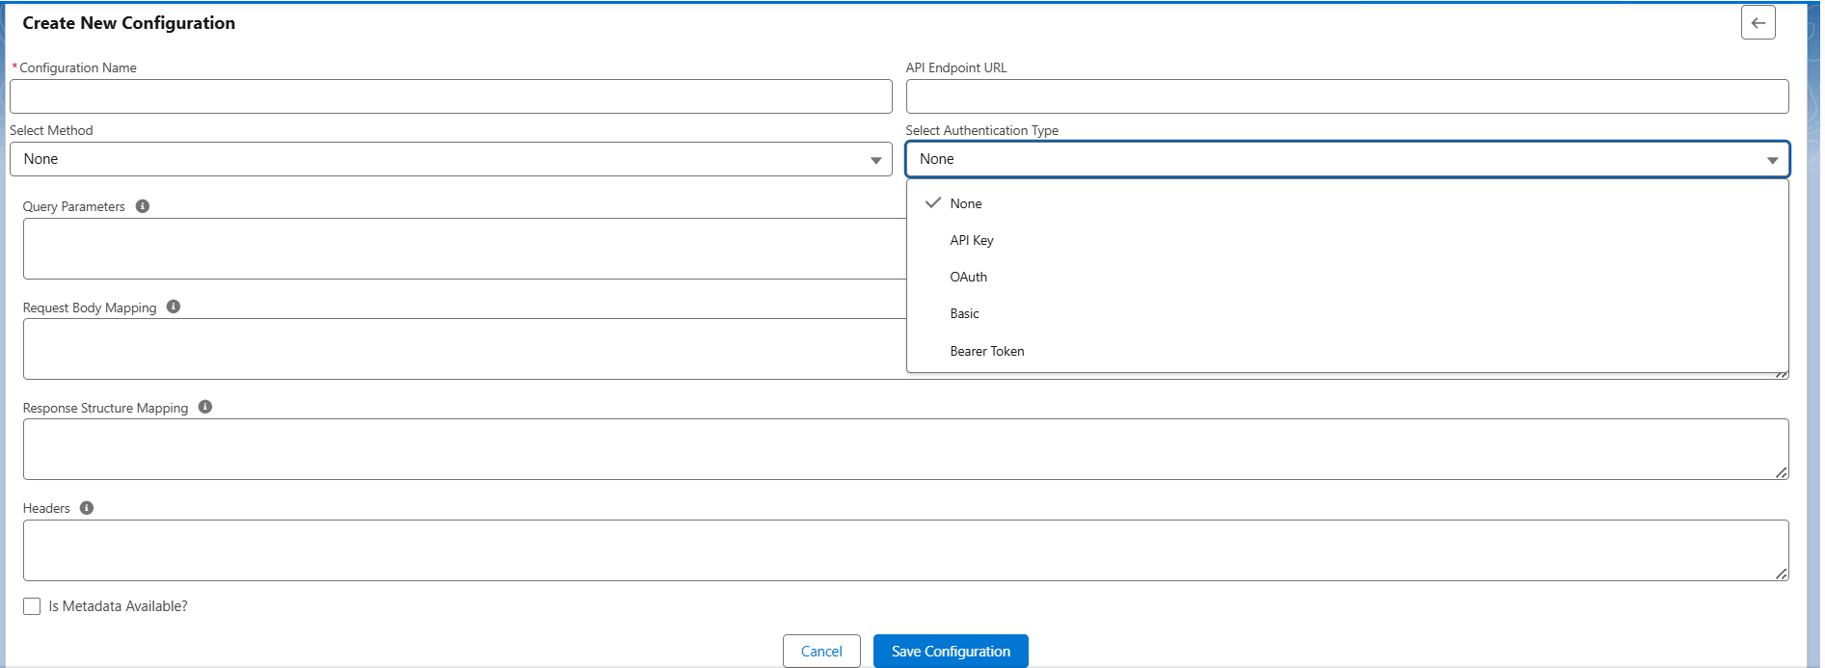
Note: Please insert the correct JSON format for fields such as Query Parameters, Request Body, and Response Structure Mapping
Example:
{
"searchkeywordkey" : "searchKeyword",
"parentidskey" : "parentIds"
}

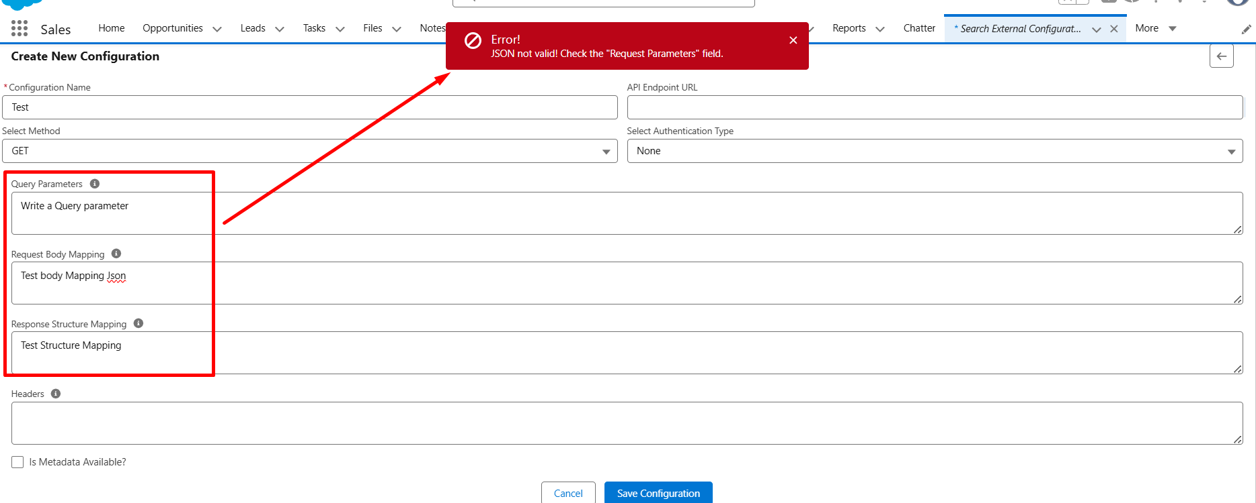

If metadata is available, select "Is Metadata Available" and enter the relevant metadata details, such as Object Name, Matching Field for Query, Parent ID Field Name, and Parent SObject Field Name.
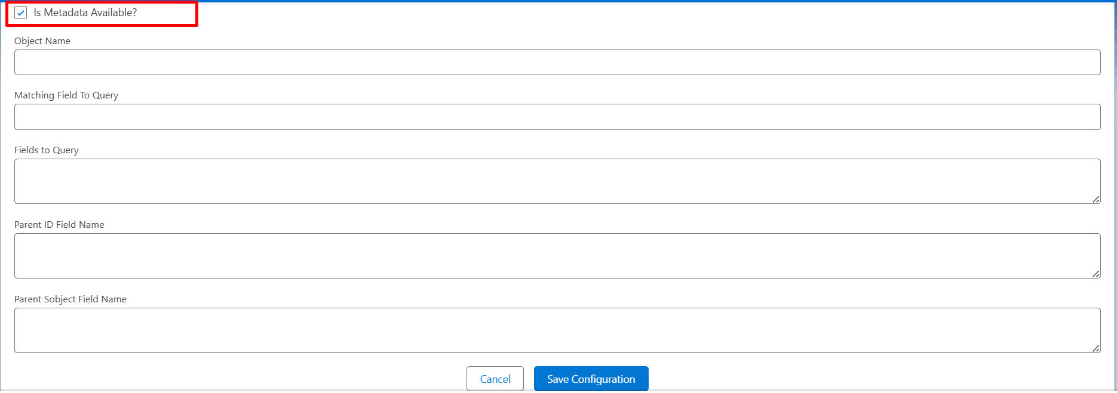
Once the configuration is successfully created, ensure that a remote site setting is automatically added in Salesforce if an endpoint is provided.
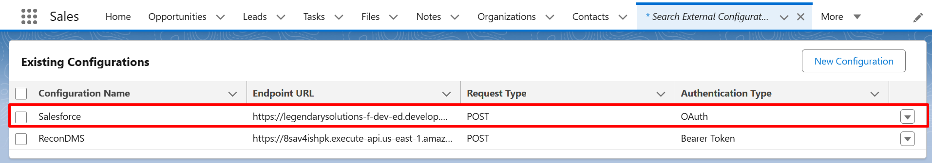
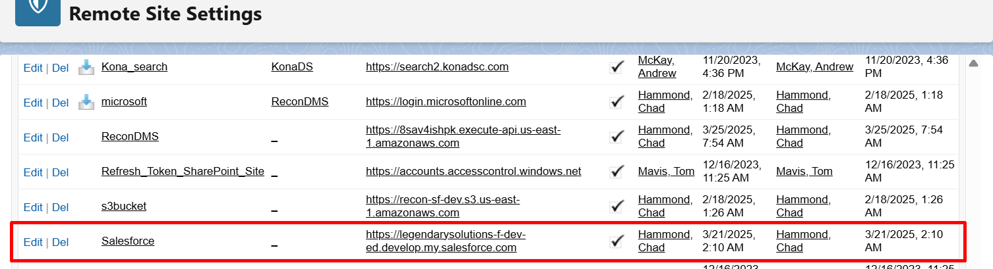

After creation, if any modifications are required in an existing configuration record, select the “Edit” button, update the desired fields, and modify their values.
If the existing configuration is not required, click the delete button to remove the record.
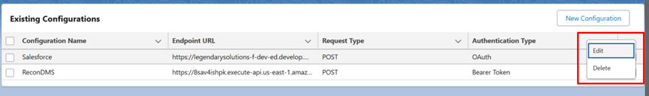

If there are any changes to the “API Endpoint URL,” ensure that the updated URL is also reflected in the Remote Site Settings.
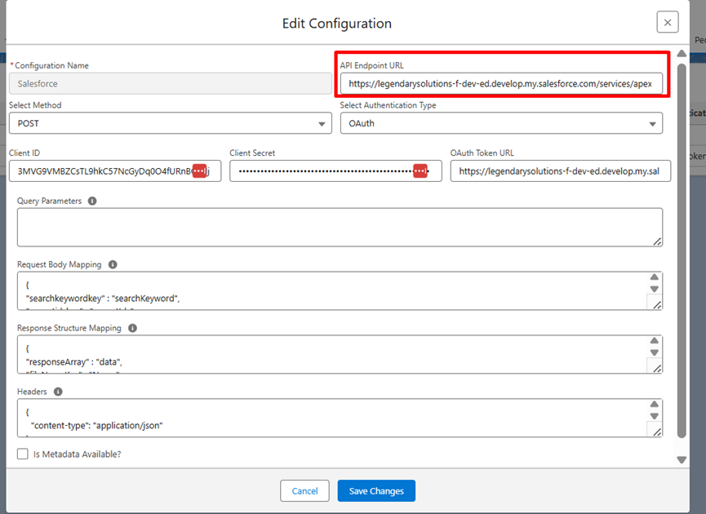

Enabling Dynamic Search for Any Object :
Navigate to the desired object and click on the highlighted icon.
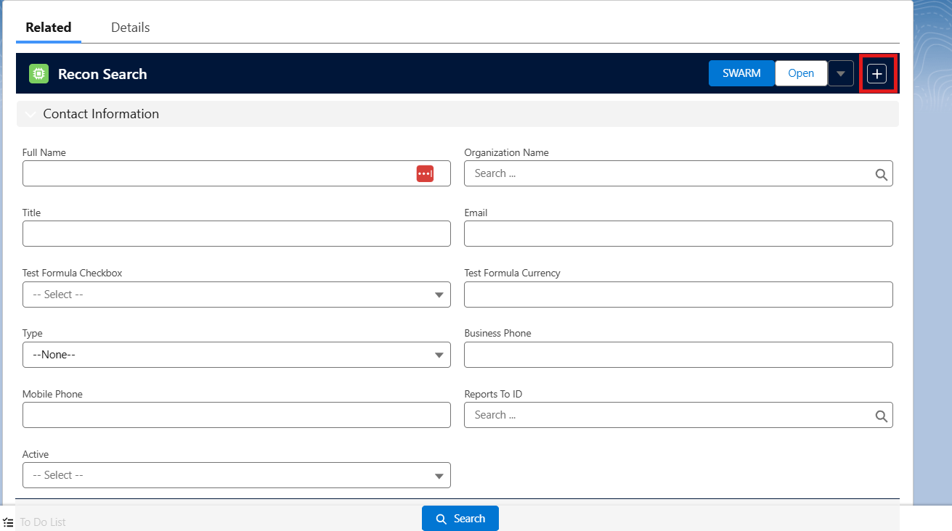

Select the Page Layout.

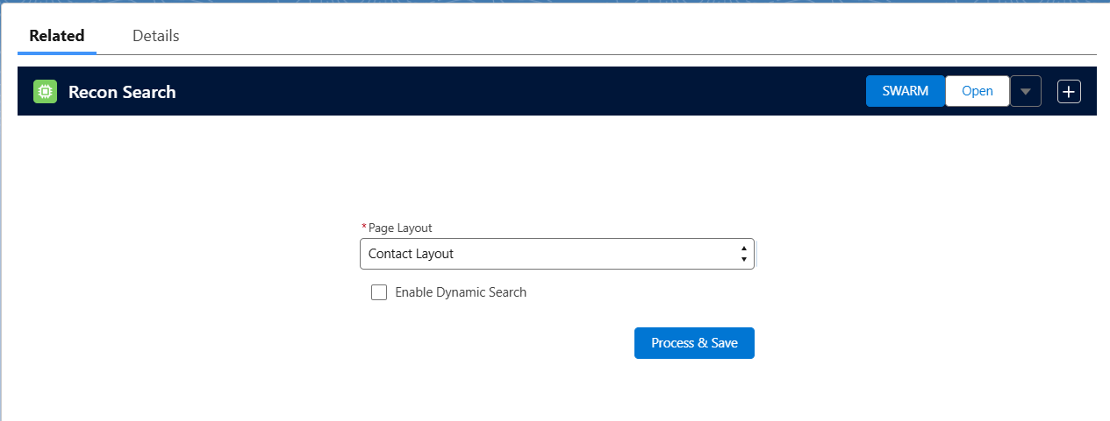

Check the "Enable Dynamic Search" checkbox, as shown below.
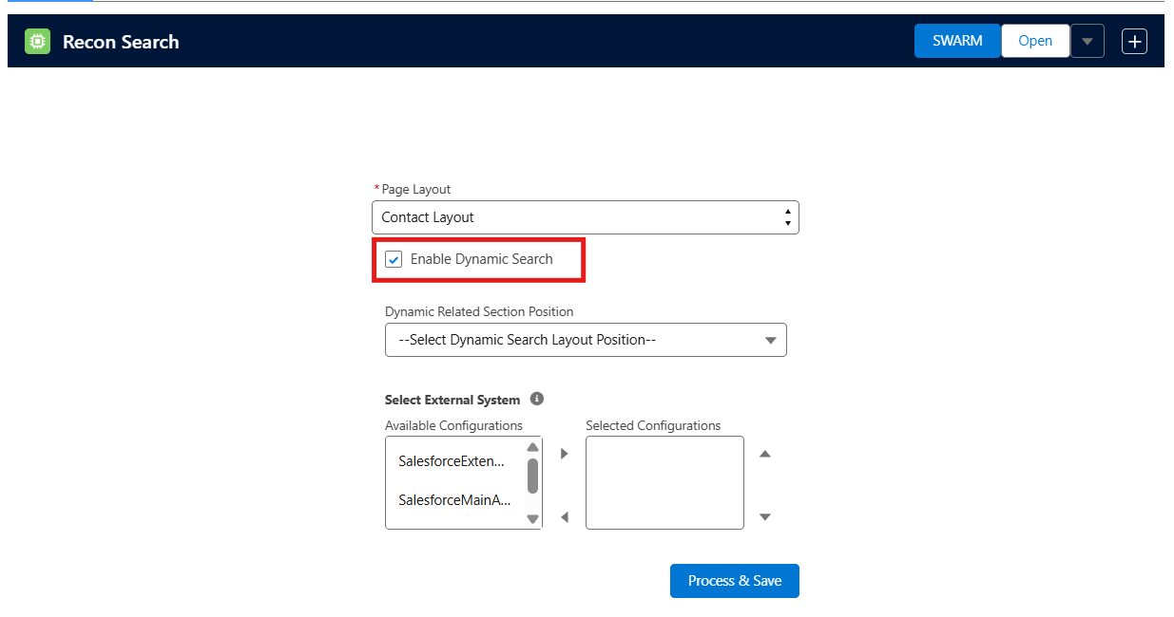

Once enabled, two additional sections appear:

Dynamic Related Section Position -

Options include "At Top of Related Lists" and "At Bottom of Related Lists."
At Top of Related Lists : If chosen, the section and fields for external searches will appear above the related list section.
At Bottom of Related Lists : If chosen, the section and fields for external searches will appear at the bottom of the related list section.

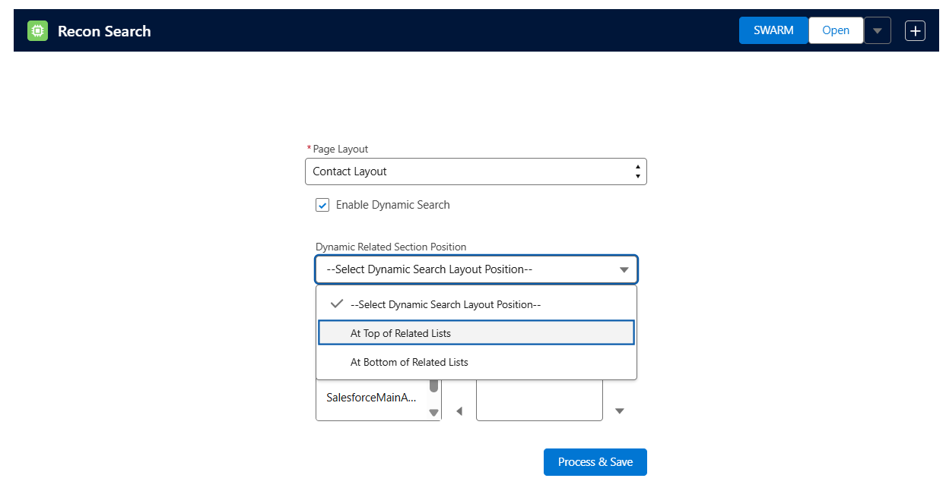

Select External System :
This section enables you to choose the external systems for which you want to add fields.

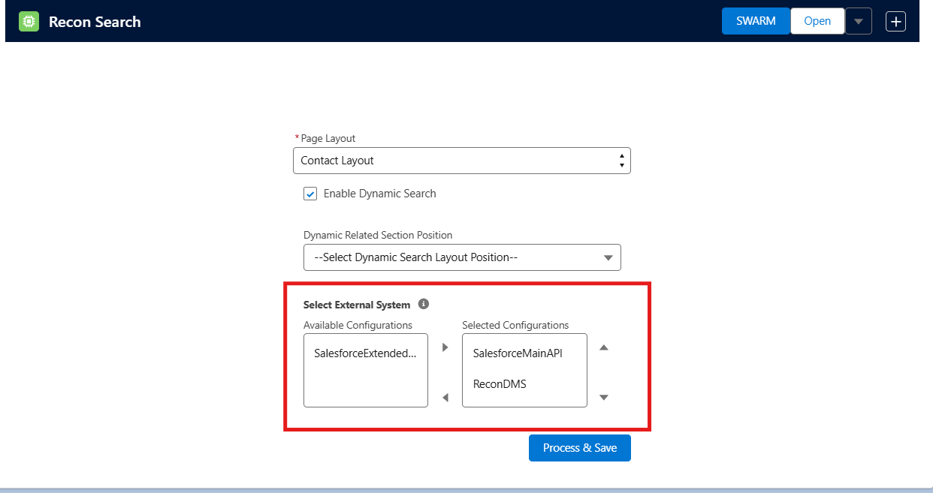

After choosing the systems, click on Process & Save. You can locate the search sections within the search component and start typing your desired keyword in the external search field.
